1.
Create a table listing the main functions and typical ports used by switches, routers, hubs, firewalls, and access points in a home WiFi setup.

Device | Main Function | Typical Ports/Connections
Switch | Connects multiple devices within the same network and forwards data to the correct device. | 5, 8, 24, or 48 Ethernet (RJ-45) ports, Console port, Power port
Router | Connects the local network to the Internet and routes data between networks. | WAN port, LAN Ethernet ports, Console port, Power port
Hub | Connects multiple devices and broadcasts data to all connected devices. | Multiple Ethernet (RJ-45) ports, Power port
Firewall | Filters incoming and outgoing traffic to improve network security. | WAN port, LAN ports, Console/Management port, Power port
Access Point (AP) | Provides wireless (WiFi) access to devices and extends wireless coverage. | Ethernet port, Antennas, Power port (or PoE port), Console port (some models)

2.
Given images or diagrams of network devices, label each device and mark the ports (Ethernet, console, power, antenna) for at least three devices.
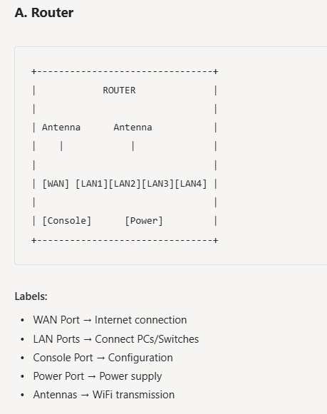
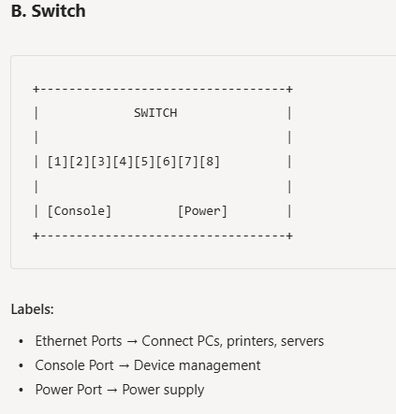
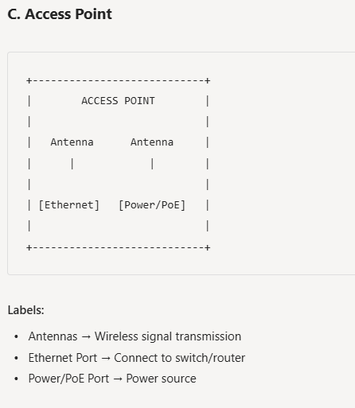

3.
Pick a popular app you use daily (like Instagram, Zomato, or Paytm) and describe in 3-4 lines how at least two different network devices (from switches, routers, firewalls, access points) play a role when you use that app.

When I open Instagram on my smartphone:
- The Access Point (AP) provides the WiFi connection and allows my phone to connect wirelessly to the college or home network.
- The Router receives Instagram data requests and forwards them to Instagram's servers through the Internet.
- If a Firewall is present, it checks and filters traffic to prevent unauthorized access and improve security.
- A Switch may connect the router, access point, and other wired devices within the local network.

4.
Suppose your college WiFi is slow and sometimes disconnects. Based on the features of access points, switches, and routers, suggest one possible reason for the issue and how upgrading one device could help.<br><br><em><strong>Hint:</strong> Think about device capacity, coverage, and traffic handling.</em>

Possible Reason
The college Access Point may be overloaded because too many students are connected to a single AP. This reduces bandwidth per user and causes frequent disconnections.
Upgrade Solution
Upgrade to a higher-capacity Access Point with support for more simultaneous users and newer WiFi standards (such as WiFi 6). This improves:
- Device handling capacity
- Wireless coverage
- Connection stability
- Overall network speed
Alternative Reason
The Router may not be able to handle heavy traffic during peak hours.

